Name______________________________________ Date:_________________
T: Investigation - Which Objects float and sink?
Object | Material | 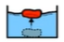  Float | 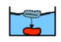  Sink
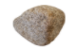
Stone or rock
Pencil
Cotton ball/pad
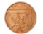
Coin

Choose 2 more objects to test.

